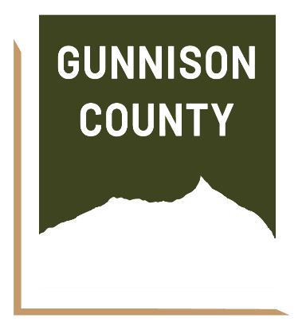
FOR IMMEDIATE RELEASE
Media Contact:
Patty Dowd Schmitz
Gunnison County Communications Director
970-648-4278 | pdschmitz@gunnisoncounty.org

Gunnison County Issues RFP to Launch Gunnison to Mt. Crested Butte Comprehensive Corridor Plan

Gunnison, CO — [December 16, 2025] — Gunnison County has issued a Request for Proposals (RFP) seeking a qualified consultant or consultant team to lead the development of a Gunnison to Mt. Crested Butte Comprehensive Corridor Plan—a major, multi-year planning effort that will shape the future of the Highway 135 corridor for decades to come.
The project will serve as a comprehensive plan for the County’s primary population, economic, and service corridor along Highway 135 from Gunnison to Mt. Crested Butte; it will integrate land use, transportation, utilities, housing, schools, recreation, agriculture, and environmental protection into a single, long-term vision. The planning process is expected to begin in spring 2026.
“This will be the most comprehensive and inclusive planning process Gunnison County has ever undertaken,” said Cathie Pagano, Assistant County Manager for Community and Economic Development. “This effort is about clearly defining our collective vision for the next 20 years—grounded in the communities’ priorities and values and taking into account where growth is appropriate and where it isn’t. The goal is to work with the community to identify where future growth makes sense and how it can best serve the communities’ needs, priorities and goals and ensure we’re making thoughtful, coordinated decisions that serve the entire valley over the long term.”
As Cathie Pagano will be moving on from her role with the County at the end of January 2026, the project will be led by Gunnison County Planning Director Hillary Seminick.
A Regional, Collaborative Approach with Clear Goals
Gunnison County is leading this effort in close collaboration with regional partners, including the Towns of Crested Butte and Mt. Crested Butte, the City of Gunnison, Crested Butte South Property Owners Association, RTA, and Mountain Express. The budget for this project is expected to be approximately $635,000, which will be supported by a $200,000 state grant as well as contributions from our regional partners.
The resulting plan will be created with significant public input and has several goals:
- Establish a clear land use vision aligned with community priorities
- Improve transportation, transit, and multimodal connectivity
- Identify infrastructure needs and constraints
- Protect wildlife habitat, agricultural lands, and natural resources
- Support compact, connected communities in appropriate locations; and
- Streamline regulations and reduce uncertainty for residents, landowners, and developers.
Importantly, the County does not expect consultants to create new data sets; instead, the project will build upon existing information related to wildlife, agriculture, and natural hazards.
Focus on the North Valley and Community Tradeoffs
Commissioner Laura Puckett Daniels emphasized the importance of the planning effort for residents of the North Valley and the broader community.
“The Highway 135 corridor is central to our County, and the decisions we make here affect everyone—especially our North Valley communities,” said Puckett Daniels. “Earlier this year, there were calls for a development moratorium in this area, but we ultimately determined that state law limits a pause to six months and would not address the applications already in progress (Starview and Lower Verzuh), so it wouldn’t have had the impacts the community desired nor provide the long-term clarity our community is asking for. This plan is about doing the harder—but more meaningful—work: having honest, transparent conversations about priorities and tradeoffs, making sure growth happens in the right places with the right infrastructure, and protecting the things that make this valley special. Change is upon us, and if we don’t meet it head on, our community will continue to evolve, but with less input and direction from us. This process gives us the opportunity to step back and ask where we want to go in the future.”
Robust Public Engagement
The Comprehensive Corridor Plan will be shaped through an extensive community engagement process conducted throughout the planning period.
“A plan of this scale only works if the community is deeply involved,” said Cathie Pagano. “This isn’t a check-the-box process. We’re committed to meeting people where they are, having honest — and sometimes difficult — conversations about priorities and tradeoffs, and ensuring that the final plan reflects not just technical analysis, but the values of the people who live and work here.”
Engagement will include monthly meetings with a regional Project Advisory Committee as well as coordination with schools, utilities, emergency services, agricultural and conservation partners, special districts, and major employers. County staff and advisory members will also host community pop-ups at existing events and gathering places, supported by a project website and transparent reporting of public input.
“We know these conversations can be challenging. Folks’ concerns about change are deeply felt,” said Puckett Daniels. “This process is about listening, asking hard questions, and being transparent about choices—whether that means enabling development in some areas or constraining it in others—so the corridor evolves in a way that aligns with our long-term goals and shared community values.”
Next Steps
The RFP is now available on the Gunnison County website at https://gunnisoncounty.org/bids.aspx?bidID=101and on Bidnet, a national RFP publishing platform. Proposals will be reviewed in early 2026, with consultant selection anticipated in advance of a spring 2026 project kickoff.

# # #

